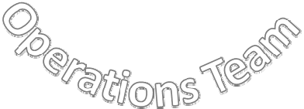
Champaign‐Urbana Cradle to Career (CUC2C)

Mission: To coordinate and align community resources to ensure the success of all our children and graduates

Leadership Council ‐ Composed of all entities actively involved in the work of CUC2C. The Council provides vision, and support based upon community response.

Steering Committee ‐ Composed of representatives selected by the Council. The Committee provides leadership and directions based on the mission of CUC2C.

Operations Team ‐ Composed of the Coordinator(s), the Data and Communications Managers, and the group facilitators. The team oversees and supports the Goal Groups.

Goal Groups – Composed of professionals and community members committed to “moving the needle” on a specific goal‐related outcome.

Champaign Urbana Cradle to Career (C2C)

Vision: A thriving community where every child achieves and every graduate succeeds.

Mission: To coordinate and align community resources to ensure the success of our children and graduates

Aspirations (Goal Groups):

- Every child is prepared to learn when entering kindergarten.

- Every student succeeds to his or her full academic potential.

- Every student is trained to be work force ready.

- Every student graduates high school.

- Every student completes some form of post-secondary education or training.

